**5. Git Clean and Push**

1. Move to project folder

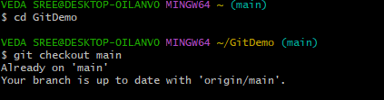

1. List out all the available branches.

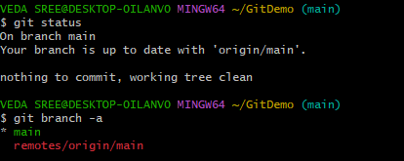

1. Pull the remote git repository to the master
2. Push the changes, which are pending from **“Git-T03-HOL_002”** to the remote repository.